Domain Analysis – ML Model for Value Investing

1. Summary & Problem Context

1.1 Summary
This project will be in the context of the financial domain, specifically stock markets. In this domain there are business especially funds that try and find methods to profit from the stock market. They try and use different methods to try and have an edge over competitors.
One of these methods is called value investing. It is a methodology with key users as Warren Buffett and Benjamin Graham. The methodology, is about trying to identify undervalued companies based on company data and market sentiment. And see if a company is worth more or less then it’s market capitalization.
Example:
Heijmans is publicly trading on the stock market with a total market capitalization for 500 million euros. When we look at the companies data for example anual filings we can see that Heijmans owns 1 billion euros worth in equipement alone. In this case Heijmans company owns more then it is worth on the stock market thus classifying it as undervalued. Because if any person would buy Heijmans for 500 million they’d technically immediately make a profit cause with that they buy the 1 bilion worth in equipment.

1.2 Problem Context

Goal 1
The problem we try and solve is about if we can use machine learning models to analyse if companies are over, fairly or undervalued to make it a more efficient process. Since currently these processes are mostly done manually by highly paid analyst.
Initial conversations with Hans showed potential issues with trying to use machine learning to classify business as over or undervalued based on that there is no objective truth. Making and training a model this way would require to manually classify business in a financial reports dataset as overvalued or undervalued at any given time based on a specific definition of when the business is overvalued or undervalued. The problem with this is that the whole definition of over or undervalued is objectively based. One person might have a different definition then someone else. And if you classify the dataset based on someones opinion. Where after you train a model on this set. The model wouldn’t actually learn how to predict overvalued or undervalued. It would just learn the initial classification set by the person in the dataset. Hereby creating a model that is in a loop which can’t actually really predict overvalued or undervalued businesses, it can just predict the persons definition.
This was later confirmed also in the expert interview by stakeholder that one of the aspect they use to classify businesses is looking at the financial reports like quarterly filings and using certain formulas like EV/EBITDA or P/E ratios to identify potential undervalued or overvalued companies. The stakeholder confirmed the financial ratios are nothing more then formulas of existing raw data. The stakeholder did however say this is only one part of finding business as over or undervalued and it needs alot more then that.
Because of this for now we will put classifying businesses as undervalued or overvalued. As a secondary goal, that it might still be possible but would require more research and understanding is a more complex problem then initially thought.

Goal 2
Therefore we will look at another option where we try and predict prices based on financial data. As made clear in the expert interview. An important value for the stakeholder is to try and identify the future prices of a stock. This because where classic value investing believed in arbitrage trading. Where you try and find business that are worth less then they’re trading for like the heijmans example is based on intrinsic value. Which also produces its own problems cause who says your business is worth what you think.
The more modern approach to value investing adapted cause with the rise of computers. Markets became more efficient, which made alot of the classic value investing arbitrage trading options dissapear. The more modern approach is where investors try and see what a business will be worth in the future. And they try and see with different methods if the price the business is currently trading for is less then the expected future price.
Herefore it is for the stakeholder important to be able to accurately predict future prices of businesses. This is were we can try and use machine learning to try and find patterns or correlations in financial reports that are predicitive of future prices. Instead or in addition to their current usage of reports from Goldman Sachs or Keppler.

1.3 Research Question
Primary:
Can we use machine learning to predict prices based on financial reports?
Secondary:
Can we use machine learning to classify business as over or undervalued?

2. Stakeholders

2.1 Who are they?
For this project I have found two stakeholders:
- Amin Bouras – friend who is currently working as a IT implementation consultant with a background in data science
- Edwin Slaghekke – Head of Investments at Ambassador Vermogensbeheer. Fund that manages around 1 billion euros in investor capital using value investing methodology.

2.2 Use for stakeholders
Amin due to his background in data science I can use when designing and building my model, for cross validation. And get a different angle of input.
Edwin I want to use to map what it is that true funds look at to value companies over, fairly or undervalued. Or to try and see if prediciting prices is important and how they do it. I will try to setup a interview to get this information.

3. Data

3.1 Which data we need
Searching online one of the most common used methods in value investing is analyzing financial filings and using stock price history. The reason for this is because they are very reliable and available. Publicly traded companies are required by law to share quarterly and yearly filings truthfully with the public. Also they can be seen as an objective truth since a dataset containing financial reports like filings contains just numbers like revenue, profit, etc. The point is that any person who would have full access to the business and would analyse the business would eventually get the same numbers. In the U.S even accounting in financial reports is done by using a framework called GAAP which all filings have to be done in and is federally regulated and enforced by the SEC, which furthermore strengthens the reliability of the data.

3.2 Where do we get the data
As mentioned previously public traded companies are required to share truthful filings these are shared with S.E.C. (Security Exchange Comission). This is a federal goverment instance that overlooks all businesses. The S.E.C. manages a online registery freely available to the public containing all publicly traded companies filings at SEC.gov. SEC.gov offers a Edgar API which you can use to retrieve any financial data needed. However it gets returned as XRBL format and requires alot of formatting and parsing. Before being a usable dataset for a machine learning model. So we will keep this in mind for later.
Alternitavely Kaggle offers already cleaned up datasets of these same filings. If so this would reduce the need for cleaning up the data. So we can try and cross-examine and validate the Kaggle dataset with the one from S.E.C. to check for it’s accuracy. https://www.kaggle.com/datasets/pacificrm/financial-sheets is the exact type of dataset were looking for except it’s about Indian companies and we want to analyse European/US markets.
Another option is SimFin. It is a platform specialised in providing financial datasets such as, share prices, financial statements, ratios, etc. For the usage of quantitave algorithms it provides US and European markets. The financial sets are clearly structured and formatted also taking into account formatting making sure there’s no differences in data between businesses. Their dataset share price ratios seems very promising for our domain. Since in the stakeholder interview it was made clear that they use certain formulas to evaluate businesses, some of those formulas mentioned in the interview are also in this dataset. It’s also a rather large dataset with 22 million rows of share price history. And the rest of the ratios differ from a range between 11 and 16 million. The only problem is that this dataset is not free but we will continue with this one.

3.3 How does the data look

FOTOS TOEVOEGEN
List below are example images of the most recent anual filing from Apple with comments below, so the Kaggle and SimFin datasets are just collections from the SEC Edgar filings.
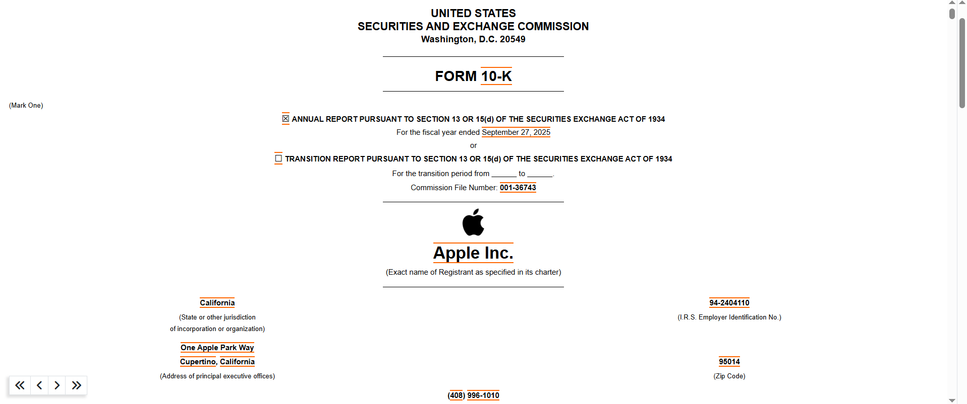
For example we can use a 10-K anual filing from Apple. That is available online as pdf or via an API by th Edgar database
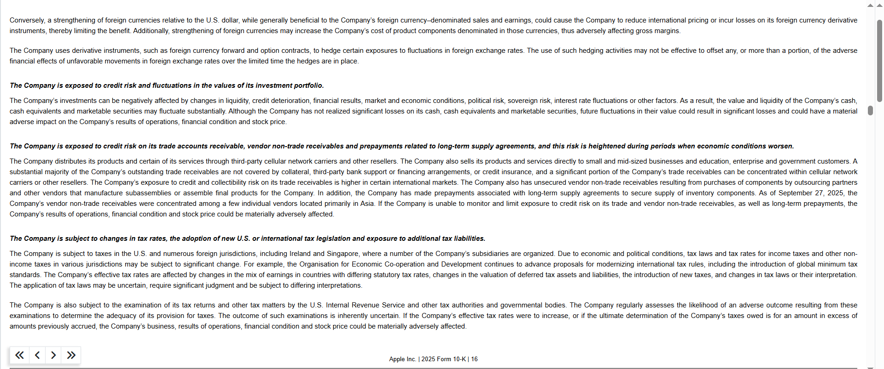
The S.E.C. filings also include textual disclaimers or announcments for investors to look at.
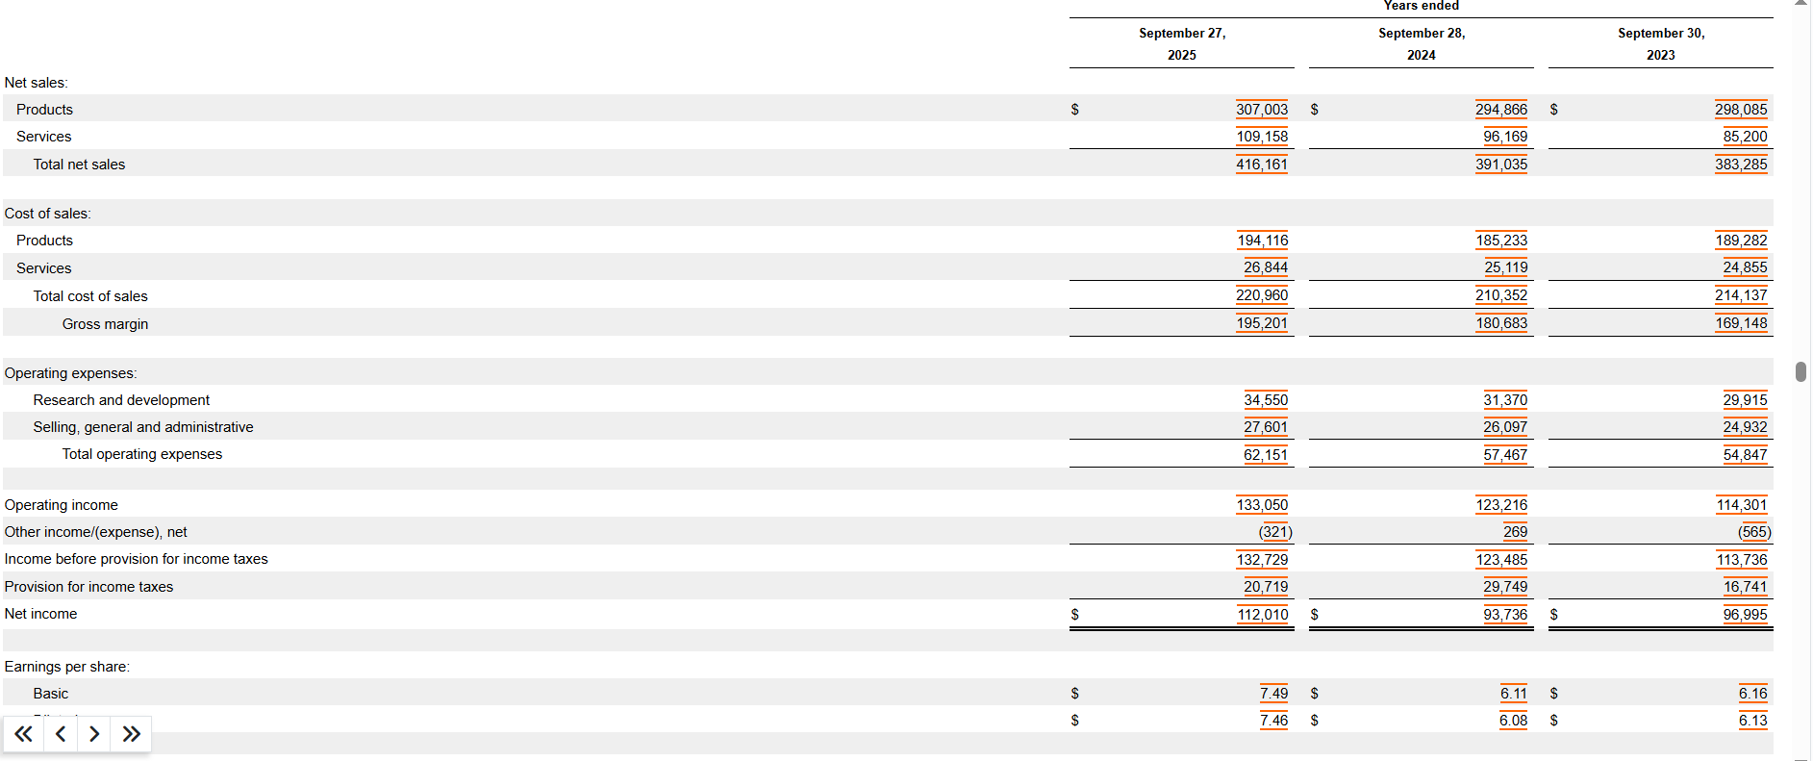
This is a small example of what the S.E.C. filings financial data statements look like
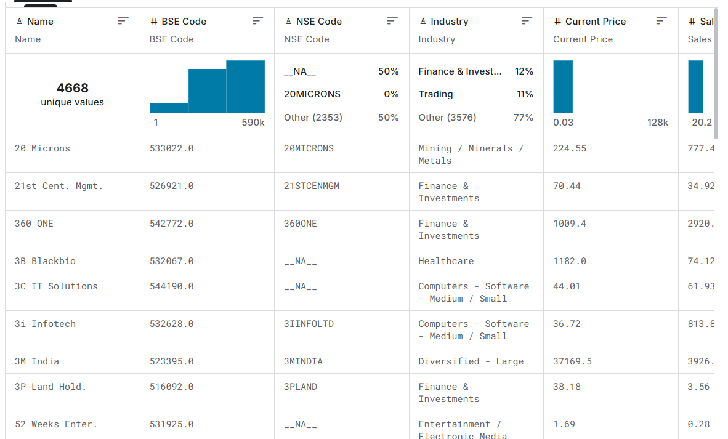
Here is the data transformed to a Kaggle dataset. It includes 58 attributes for each company. As well as bankrupt companies. Which could be useful to see if a model could predict this or even just to include it to prevent survivor ship bias, that the dataset only contains succesfull companies.
It spans multiple financial aspects, such as annual and quarterly profit and loss statements, balance sheets, cash flow data, financial ratios, and market prices.
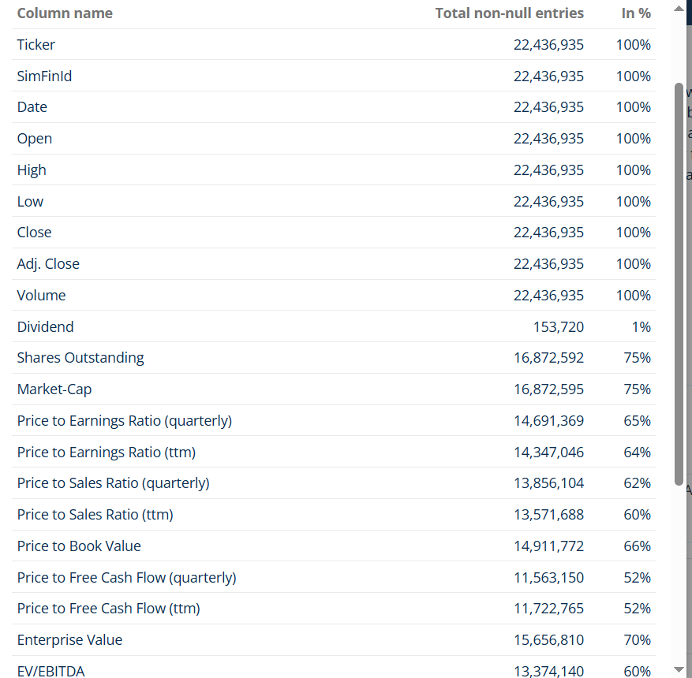
Here is a SimFin dataset derived of financial ratios. Including ratios mentioned by the stakeholder. The stakeholder mentioned for them they look at the stock price of a company. As well as other financial ratios derived from the filings which are also included in the dataset above.

3.4 Data requirements
In the expert interview we discussed with the stakeholder how they evaluate businesses and what they look at. The stakeholder mentioned some of the formulas or ratios they look at from or based on financial reports like: P/E (Price to Earnings Ratio), P/B (Price to Book Value Ratio), EV/EBITDA (Enterprise Value to Earnings Before Interest, Taxes, Depreciation, and Amortization), etc. So ideally we want to find a dataset containing these formulas and ratios.
Below is what the dataset from SimFin we will use for the initial model looks like containing these formulas and ratios:
Columns & Coverage
Please note: the coverage is mainly determined by the degree of how detailed the companies are reporting their financials.
Total columns: 28
Column name | Total non-null entries | In %
Ticker | 22,425,274 | 100%
SimFinId | 22,425,274 | 100%
Date | 22,425,274 | 100%
Open | 22,425,274 | 100%
High | 22,425,274 | 100%
Low | 22,425,274 | 100%
Close | 22,425,274 | 100%
Adj. Close | 22,425,274 | 100%
Volume | 22,425,274 | 100%
Dividend | 153,718 | 1%
Shares Outstanding | 16,859,493 | 75%
Market-Cap | 16,859,496 | 75%
Price to Earnings Ratio (quarterly) | 14,689,913 | 66%
Price to Earnings Ratio (ttm) | 14,347,489 | 64%
Price to Sales Ratio (quarterly) | 13,856,467 | 62%
Price to Sales Ratio (ttm) | 13,572,414 | 61%
Price to Book Value | 14,911,914 | 66%
Price to Free Cash Flow (quarterly) | 11,564,306 | 52%
Price to Free Cash Flow (ttm) | 11,724,712 | 52%
Enterprise Value | 15,645,790 | 70%
EV/EBITDA | 13,371,000 | 60%
EV/Sales | 13,558,629 | 60%
EV/FCF | 11,773,810 | 53%
Book to Market Value | 14,780,068 | 66%
Operating Income/EV | 14,374,898 | 64%
Altman Z Score | 11,483,836 | 51%
Dividend Yield | 7,309,209 | 33%
Price to Earnings Ratio (Adjusted) | 14,310,155 | 64%

One thing that should be noted that is clear is that there is a difference between available share price data which is 100% about 22 million rows. And financial ratios/formulas which ranges between 50% and 75% about 11 million to 16 million rows. So obviously in the model we gonna have to look where to missing values are. And what those missing values would mean for our model and how we want to handle them.

3.5 Analytic Approach

3.5.1 Target variable
Since we want to build a model to predict stock prices. The obvious target variable is gonna be price. However an important note on this is that in the domain context we want to predict stock prices in the future. This because the stakeholder made clear in the interview that’s what they need for their financials analysis, the stakeholder mentioned they look at reports that predict stock prices about one year in the future. So this is what we are gonna try and predict.
This will present a technical challenge in the dataset and model training. In making sure not to leak any data to the model. As well as in the SimFin dataset each financial data row contains a date and ticker symbol which has a corresponding price in a seperate dataset with same date and ticker symbol and share price. So this would be the logical place to connect the datasets. However when we train the model for each financial data row we don’t want the current price. But we want the price in the future of a certain period.

3.5.2 Nature of the problem
Since we have two datasets containing share prices, dates, ticker symbols, and other financial ratios. Our dataset contains the target variable as well as other features.
In machine learning this would immediately steer into supervised learning since our dataset contains our target variable as well as other features.
Since we’re doing supervised learning the primary goal is predicting prices which will be a regression problem. The secondary goal is trying to find out if business are overvalued or undervalued which would be a classification problem.

3.5.3 Indicators
Based on the expert interview were there was said that ratios and formulas are used to analyse companies. We can see in the dataset that it contains some of these figures as columns. Herefore we we hope that a Exploratory Data Analysis will reveal that there will be positive correlations between the target variable and features from the dataset. If this isn’t the case or the correlations aren’t sufficient. We can try and use other datasets from SimFin consisting of more raw financial data to try and find correlations with the target variable.

3.6 Data Diversity
The dataset we use contains a big collection of different companies in different financial scenarios. From large companies performing really well, to small companies performing poorly and everything in between. With that it also has all the necessary data for stock price history as well as financial data formulas and ratios. In a wide range spanning 20 years.

As previously mentioned or dataset contains objective truths. So there is no need for training a model on different datasets since they will all just provide the same data. We just have to check that the data from the dataset we use is accurate.

3.7 Data Dictionary
Identifiers
Ticker: Company trading symbol
Date: Date of the observation (price + ratios)

Price / Market
Adjusted Close (Target Variable): Realistic price including dividends and splits. Used for return calculations.
Volume: Indicates market activity and sentiment around a stock.
Market Cap: Company size. Smaller companies may have more pricing inefficiencies.

Valuation (Core for value investing)
P/E (ttm): Price relative to earnings. Used to assess how expensive a company is.
P/S (ttm): Price relative to revenue. Useful when earnings are less reliable.
P/B: Price relative to assets. Classic value investing metric.
P/FCF (ttm): Price relative to free cash flow.
EV/EBITDA: Measures value based on operational cash flow. Widely used by professionals.
EV/Sales: Alternative valuation when profits are unstable.

Value Signal
Book to Market Value: Inverse of P/B. Indicates how “cheap” a stock is relative to its assets.

Quality (avoid value traps).
Operating Income/EV: Measures profitability relative to company value.
Altman Z Score: Financial health indicator. Helps detect risk of bankruptcy.

Optional
Dividend Yield: Income return from dividends.
Stakeholder mentioned dividend as an important anchor in valuation shows reliability of company.

Data Choice
The dataset contains both quarterly and yearly (TTM) data we will use past data of 3 years.
For this model, TTM data is used because:

It reduces short-term noise
It better reflects long-term earning capacity
It aligns with how the stakeholder evaluates companies with long term vision in mind mentioned in the expert interview transcription.

4. Assumptions and Risks

4.1 Data related risks
Partial Disclosure
Companies are not required to disclose all internal financial information.
Formatting / Creative Accounting
Companies may present financial information in ways that make their performance appear more favorable. Also there can be big differences in the way companies publish filings. Since the model has to learn price or overvalued/undervalued based on financial data.
Fraud Risk
There are historical cases of companies manipulating financial reports to inflate earnings.
Despite these challenges, the advantage of this domain is that data availability is very high, since public companies must regularly publish financial reports.

4.2 Model related risks
Cautious Model
If the model is made to cautious of classifying a company as undervalued. It might filter out potential undervalued opportunities for analyst.
Wrong predictions
If the model wrongly predicts the stock price. Analyst might wrongly identify stocks as buying opportunities potentially causing huge losses.
Different factors
A companies numbers in filings can heavily change due to different factors, macro economic events, management changes, market sentiment, etc. So past numbers may not be indicative of future results. Partly because there are just so many factors able to influence the numbers.
Overfitting
One of the risks in building and training the model is overfitting. Since we want to predict stock prices and classify for under and overvalued.
Data Leakage
Data leakage occurs when the model has access to information that would not be available at the time of prediction, such as future prices or variables derived from them. From for example ratios like P/E which consists of price divided by earnings. This ratio already contains price which would leak price data to the model allowing it to learn from it instead of learning to predict it. This leads to overly optimistic performance that does not generalize to real-world scenarios. Therefore strict separation between features and target variables is required.
To ensure the model learns realistic and usable patterns, it is essential that no future information is used when predicting stock prices. This requires strict separation between the moment at which input data is available and the moment of prediction. In other words, the model must only use information that would have been known at the time of prediction.
To achieve this, a lag-based data alignment approach is applied. For each observation at time t, all input features are derived from financial data available at that same time t. The target variable is then defined as the stock price (or return) at a future time t + X, where X represents the prediction horizon (for example, 6 or 12 months).

4.3 Market assumptions
Efficient markets
The financial domain contains theories about efficient market pricing. This talks about that any change in a business would be immediately reflected in the stock price. Thus making each business stock price always fairly representing the businesses value.
This is one of the largest discussions in the financial domain and a crucial factor fort he model. There is a part of experts that agree that markets are efficient in the long run. Thus in the long run a companies stock price represents its value. However these same group of experts say that in the short term markets do have inneficiensies. Smart models or analyst would be able to exploit these inefficiencies.
This model is based atleast on the assumption that markets do produce short term inneficiencies. If markets are efficient or inefficient in the long run we leave out of this domain.

5. Scope of Model
The model is meant to predict stock prices based on financial data. A secondary goal is classifying business as overvalued or undervalued based on financial data.
We will check if the Kaggle dataset is accurate, we gonna leave out if data is fraudulent and assume all data is truthful
Since the model is only meant as a screening tool we leave out fundamental factors such as market sentiment, management changes, etc.
While it sounds obvious the model should be designed and build keeping into account the model can’t predict what it can’t see

5.1 Definition of undervalued
The definition of undervalued will be expanded on if the secondary goal is explored.

6. Model
The primary objective of this project is to predict future stock prices based on financial data. This directly defines the machine learning problem as a regression task, since the target variable (price or return) is continuous in nature.
A regression model is appropriate because it allows the model to estimate the magnitude of future price movements, rather than simply classifying outcomes into discrete categories. This aligns well with the needs of the stakeholder, who is interested in identifying potential upside and downside in stock prices.
For the initial implementation, a regression-based approach such as linear regression can be used as a baseline model. This provides a simple and interpretable starting point for understanding relationships within the data. However financial data is often non-linear and influenced by complex interactions between variables.
Therefore, more advanced models such as tree-based methods (e.g. Random Forest or Gradient Boosting) may be explored. These models are better suited to capturing non-linear relationships and interactions between financial indicators.
The final model choice will depend on performance, but the overall approach remains consistent: using regression to model the relationship between financial features at time t and future stock prices at time t + X.

7. Conclusion
The initial idea of making a model to classify businesses as undervalued or overvalued hasn’t been fully ruled out. But it is clear that it contains a lot more complexity then initially thought.
So for now it would be best to pivot to a primary goal of predicting future stock prices on financial data. We found a very well matching dataset with plenty of features that the stakeholder also uses for their financial analysis. The dataset is more then big enough with a lot of different companies in different financial scenarios and a large range of 20 years historical data.
The stakeholder identified interest for a future stock price prediction model. Based on the domain analysis building a model should be doable using linear regression.

Data requirements moeten duidelijker waarom die cijfers waarom niet andere
Vermelden over waarom jaarcijfers belangrijker zijn als kwartaalcijfers.

Source List:
Ambassador vermogensbeheer Investment Philosophy:
https://www.ambassadorvermogensbeheer.nl/over-ambassador-vermogensbeheer/beleggingsbeleid/?_gl=1*1x0lny0*_up*MQ..*_ga*NjE1MzAzMzQ2LjE3NzYyOTc0NjY.*_ga_4H0XCTZKZB*czE3NzYyOTc0NjYkbzEkZzAkdDE3NzYyOTc0NjYkajYwJGwwJGg1MjA4ODg3Mjc
GAAP Accounting Principles:
https://www.investopedia.com/terms/g/gaap.asp
Dataset Share Price ratios:
https://app.simfin.com/bulk-download
Dataset Financial sheet Kaggle:
https://www.kaggle.com/datasets/pacificrm/financial-sheets
SEC Edgar API – AAPL examples:
https://www.sec.gov/edgar/browse/?CIK=320193&owner=exclude
Machine Learning Model Choice / Target Variable:
https://fhict.instructure.com/courses/15784/pages/analytic-approach
Expert Interview – Value Investing – Edwin Slaghekke:
https://stichtingfontys-my.sharepoint.com/:w:/r/personal/517502_student_fontys_nl/_layouts/15/Doc.aspx?sourcedoc=%7B5795F9F7-3935-4172-AEA5-CD630DF321C6%7D&file=Transcriptie%20expert%20interview%20-%20Ambassador%20Vermogensbeheer.docx&action=default&mobileredirect=true&DefaultItemOpen=1

